Sometimes, ‘No goals have been specified for this build. You must specify a valid lifecycle phase or a goal in the format ‘ may occur while using options such as project🡪Run as 🡪 Maven build or maven run directly running from eclipse as follow:

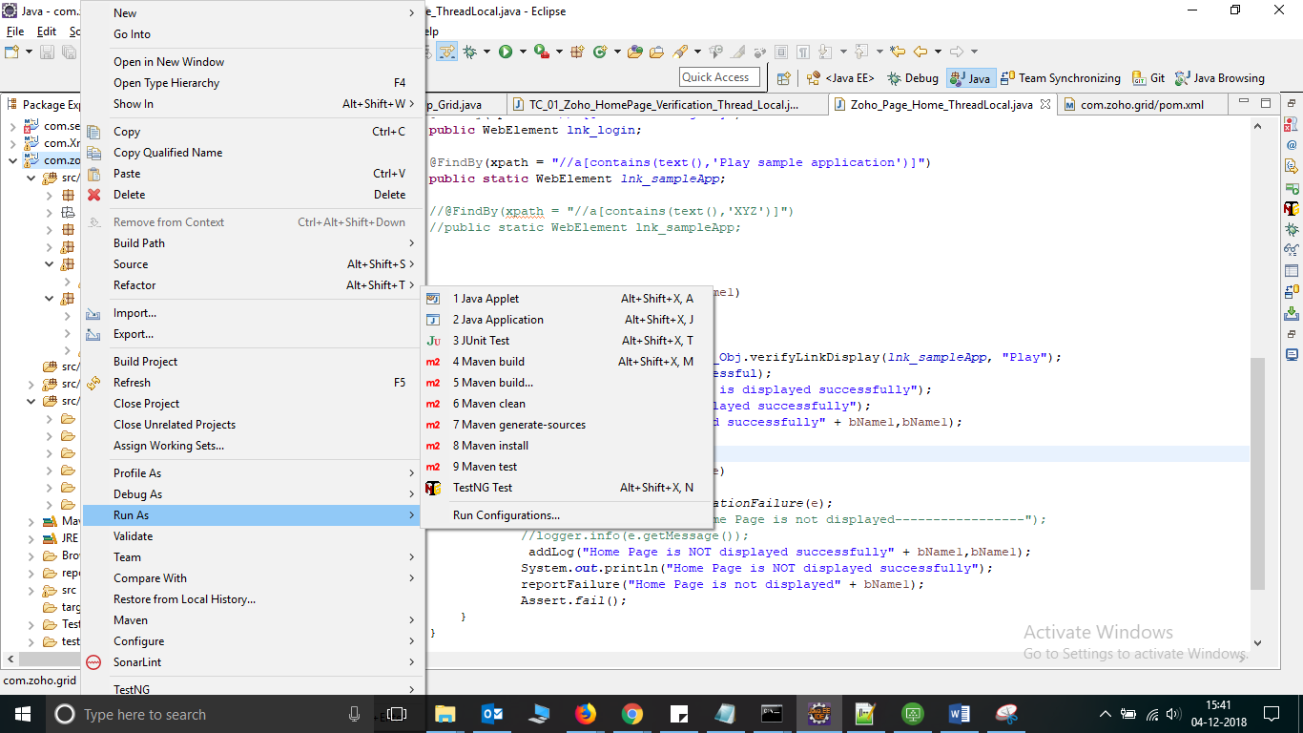

Solution: Run the following command at command prompt at project pom location. These errors will be removed.

Mvn: install

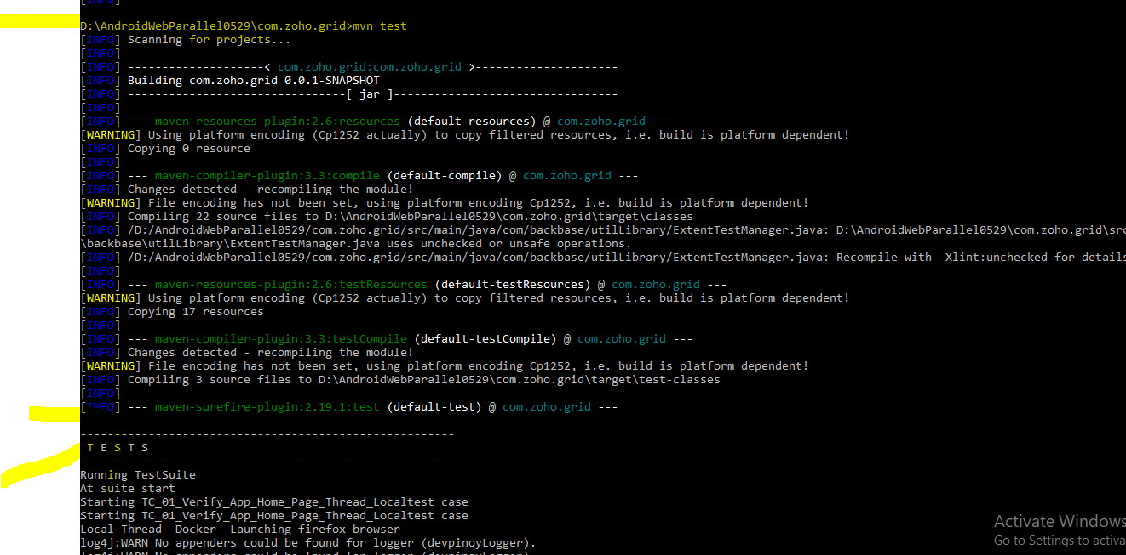

Note: Before running the above command, make sure the following setting in eclipse. Installed JRE’s should point to jdk not jre.

